**Efficacy of Chemical Applications in Controlling Soil-Borne Pathogens of Soybean Using An In Vitro Approach**

**ABSTRACT**

**INTRODUCTION**

Soybeans is a food and oilseed crop which is rich in both protein and edible oil. It is a major source of protein for both human and livestock but is prone to many disease that could cause a significant decrease in yield. As reported by (S Navi & Rajasab, 2016) in their paper, in 2013, soybean was grown in 70 countries with an annual production of 268 million metric tons with United states (31%), Brazil (31%) and Argentina (19%) being the highest producer of soybeans. However, report from the USDA website showed that in 2024/2025 (Marketing Year 2024 from September – August), Brazil is currently the largest producer of soybeans with about 169 million metric tons, followed by USA with about 118.84 million metric tons and the third largest producer is Argentina with 49 Million metric tons. The production from these three countries makes up 80% of the global population of soybeans around the world with 40% from Brazil, 28% from USA, and 12% from Argentina (USDA, 2025). This reduction in yield of soybeans varies over the years as there are many factors that could affect grain yields and some of them include environment, production practices, and a variety’s susceptibility to disease (Allen et al., 2023). In 2022, About 3 out of 4 the soybeans production in the United States comes from the northern states (Illinois, Indiana, Iowa, Kansas, Michigan, Minnesota, Nebraska, New York, North Dakota, Ohio, Pennsylvania, South Dakota, and Wisconsin) and all of these states jointly has a yield loss of 71.3% of the total soybeans loss in 2022. Seedling diseases due to Fusarium, Pythium, Phomopsis and Rhizoctonia are one of the major causes of soybeans loss in 2022 (Allen et al., 2023). Despite the advancements in soybean cultivation practices, plant pathogens continues to limit soybean yields. According to farm journal, the following soil-borne fungal pathogens (Fusarium, Rhizoctonia, Pythium, and Phytophthora) are some of the major causes of seedlings blights in soybeans and they are attributed to the loss of about 6 million bushels of soybeans in the United State and Canada in 2023 (farmjournal, 2025).

In Nebraska, the largest producer of beef and pork, Soybeans is one of the major ingredient used in the beef and pork production. However, Nebraska experiences an estimated annual loss exceeding 9 million bushels due to pathogenic organisms (CropWatch, n.d.). According to (S Navi & Rajasab, 2016), several fungal pathogens such as Colletotrichum truncatum, Fusarium virguliforme, Macrophomina phaseolina, Pythium irregulare, Rhizoctonia solani, and Sclerotinia sclerotiorum, are major contributors to soybean seedling diseases, which leads to decrease in soybeans yield. Their study evaluated the efficacy the following fungicides: Foliar fungicides picoxystrobin (Aproach®), fluoxastrobin (Evito), pyraclostrobin (Headline EC) and azoxystrobin (Quadris), pyraclostrobin + fluxapyroxad (Priaxor), trifloxystrobin + prothioconazole (Stratego YLD), and fluxapyroxad (Sercadis) on the following pathogens: Colletotrichum truncatum (CT), Fusarium virguliforme (FV), Macrophomina phaseolina (MP), Pythium irregulare (PI), Rhizoctonia solani (RS), Sclerotinia sclerotiorum (SS), Septoria glycines (SG) using an in vitro culture plug method. The result showed that, all of the fungicide except Sercadis reduced the growth of CT isolates. Headline EC, Priaxor, and Stratego YLD significantly reduced the growth of Fusarium virguliforme (FV), Macrophomina phaseolina (MP), Rhizoctonia solani (RS), and Sclerotinia sclerotiorum (SS). Sercadis was very effective against Rhizoctonia solani (RS) while Aproach and Quadris were effective against Fusarium virguliforme (FV).

The objective of this study is to investigate the efficacy of chemical applications in controlling soil-borne pathogens of soybean and to look at the tolerance of the various pathogens to fungicide at different dose level.

**Materials and Method**

This experiment was conducted to determine the effectiveness of fungicides against soil-borne pathogens in soybeans. The fungicide used was incorporated into the growth medium (petri dish) to ensure there was homogeneous distribution of this chemical across the different fungal species. To achieve this, they collected data based on the species of pathogens (isolates), different types of fungicide treatments and also at varying dose level. This experiment was setup this way so that it would mimic how the different fungicide would react with the pathogens in the natural soil conditions. The details of the experimental design is given below:

**Soybeans Pathogens**

The following isolates (species) were used in this study: Diaporthe longicolla, Fusarium oxysporum, Fusarium solani and Rhizoctonia solani.

**Fungicide**

The following fungicide was used: DelaroComplete 3 active ingr (Proth+Trif+Fluop), Endura 1 active ingredients (Boscalid), Quadris 1 active ingredients (Azoxystrobin), Topguard 1 active ingredient (Flutriafol), and Topguard EQ 2 active ingredient (Flut+Azoxys)

**Dosage**

Each of the fungicide treatment got 3 levels of doses (Dose in mg/ml) with one control.

|  |  |  |  |  |
| --- | --- | --- | --- | --- |
| DelaroComplete 3 active ingr (Proth+Trif+Fluop) | Endura 1 active ingr (Boscalid) | Quadris 1 active ingr (Azoxystrobin) | Topguard 1 active ingr (Flutriafol) | Topguard EQ 2 active ingr (Flut+Azoxys) |
| 6.292 | 4.011 | 6.1036 | 5.7975 | 4.9128 |
| 0.6292 | 0.4011 | 0. 61036 | 0. 57975 | 0. 49128 |
| 0.06292 | 0.04011 | 0.061036 | 0.057975 | 0.049128 |
| 0 | 0 | 0 | 0 | 0 |

**Response:** Radial growth rate of pathogens were measured in the presence and absence (dose = 0) of fungicides. Each petri dish had 4 measurements (radial growth), which indicates that fungi often grow unevenly, so taking multiple measurements improves precision.

The Skeleton ANOVA table based on the above design is given below.

**Skeleton ANOVA (Split-Plot Factor Factor Nested in Whole-plot factor)**

|  |  |
| --- | --- |
| **SV** | **239** |
| Treatment | (5-1) = 4 |
| Dose(Treatment) | (4-1)*5 = 15 |
| Species | (4-1) = 3 |
| Treatment*Species | (5-1)*(4-1) = 12 |
| Species*Dose(Treatment) | 3*15 = 45 |
| Error(Dish(Dose*Species*Treatment) (Random) | (3-1)*(4*4*5) = 160 |

The model specification is given as

Avg_Measurement = Species*Treatments + (1 | Dose:Treatments) + (1 | Species:Dose:Treatments)

**Where**

* Species × Treatments is the fixed effects interaction which enables us to determine how different fungal species respond to different fungicide treatments.
* (1 | Dose:Treatments): This nested structure accounts for random variability due to different doses within each treatment.
* (1 | Species:Dose:Treatments): This nested structure accounts for the random variation in species responses within specific dose-treatment combinations.

**Two-Part Model (Zero-Inflated Gamma)**

We model the growth of the fungus (mix of zero and positive values (semicontinuous)) using the two-part model as shown below

f(y) = (y|)

where , this is the parameters used in modeling the Probability of fungal growth greater than zero. (y|) follows a Gamma ( distribution with as the shape parameter, and as the scale parameter. The zero-inflated gamma distribution is given as ZIGamma(, ), where is the probability that the fungus die (y = 0),while provides information about the gamma distribution, the non-zero part of the model. For the zero-inflated gamma model, the probability that the fungus does not die is modeled using the logistic regression while the distribution of the non-zero i.e. growth of fungus is modelled using the gamma distribution with a log-link. (Mills, 2013)

**Model Structure**

This study performed a zero-inflated Gamma model to look at the effects of species, and treatments on the average fungal growth (positive continuous measurements with an excess of zeros), while also accounting for the nested structure of dose. This model was fitted using the “glmmTMB” package in R

* The nonzero part (positive fungal growth) was modelled using a Gamma distribution
* The zero-inflated part which model the probability of an observation being structurally zero was modelled using a logistic regression.

The gamma component consists

* main effect of species, and treatment,
* Interaction between species and treatment, and
* The random effects for dose nested within treatment.

The zero-inflated component includes only the intercept assuming a constant probability of excess zeros across groups.

, **,** where

* =
* Logit(

is the average measurement for the ith species, jth fungicide treatment, kth dose and ith dish.

is the baseline log mean fungal growth

is the overall error term.

**Zero Inflation Model**

is the intercept

**Explanatory Analysis**

Figure 1 shows the distribution of fungal growth across different type of treatments. Since the fungus spreads out like a circle as they grow, four measurements were taken: from the center to the top (measurement 1), center to the right (measurement 2), center to bottom (measurement 3), and center to the left (measurement 4). Figure 1 thus shows that the mean growth across the various measurements were similar across directions, thus we took the average of the four values for each experimental unit. Figure 2 shows the average fungal growth across different treatments. The plot shows Quadris 1 active ingredient has the highest average fungal growth followed by Endura 1 active ingredient, Topguard EQ 2 active ingredient and Topguard 1 active ingredient. As also observed from figure 3, Quadris 1 active ingredient (Azoxystrobin) showed the highest median fungal growth and the greatest variability, this suggests that this treatment was less effective in fungal control compared to the other treatments. Endura 1 active ingredient (Boscalid) had the next highest median growth but exhibited slightly less variability. Topguard 1 active ingredient (Flutriafol), Topguard EQ 2 active ingredients (Flutriafol + Azoxystrobin), and DelaroComplete 3 active ingredients (Prothioconazole + Trifloxystrobin + Fluopyram) had lower median fungal growth, which suggest better overall control of fungal spread.

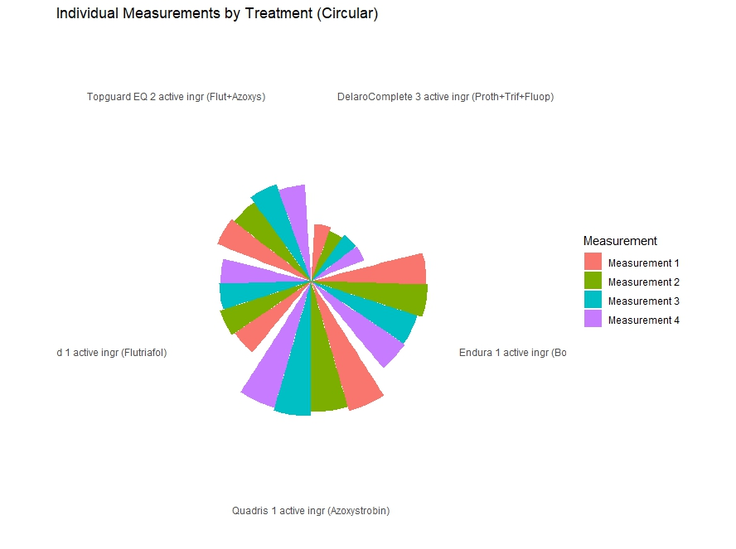

*Figure 1: Circular plot showing the distribution of fungal growth values for each measurement taken across different fungicide treatments.*

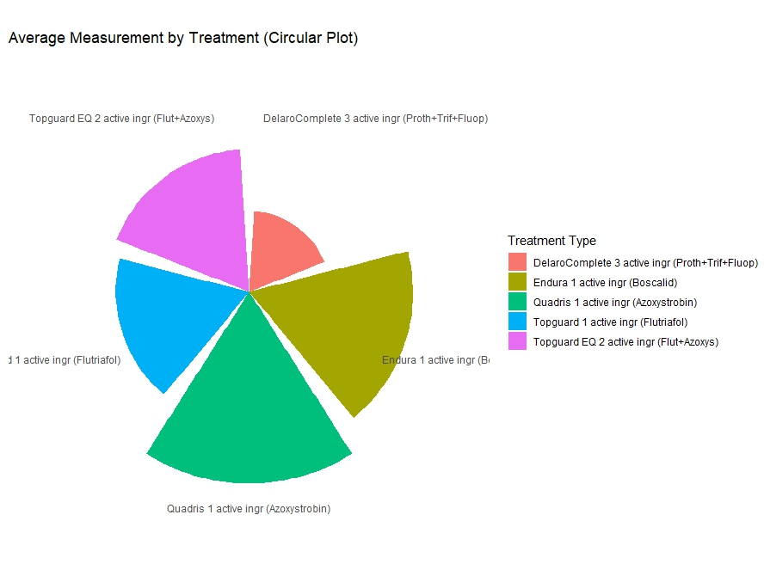

*Figure 2: Circular plot showing the distribution of average fungal growth across different fungicide treatments.*

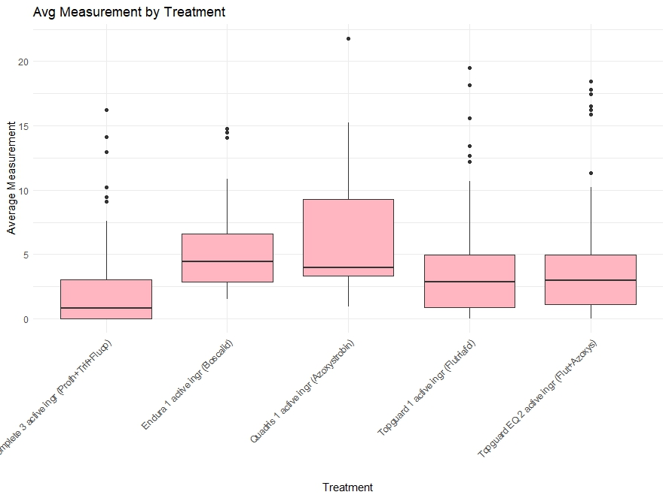

*Figure 3: Boxplot showing the distribution of average fungal growth measurements across different fungicide treatments.*

Figure 4 shows the distribution of fungal growth across different species. As also observed in Figure 1, the the mean growth across the various measurements were similar across directions, Figure 5 shows the average fungal growth across species. Fusarium oxysporum grows the highest, followed by Rhizoctonia solani, Fusarium solani and Diaporthe longicolla. Also, from figure 6, we were able to confirm that. Fusarium oxysporum has the highest growth under the experimental conditions, while Diaporthe longicolla has the least.

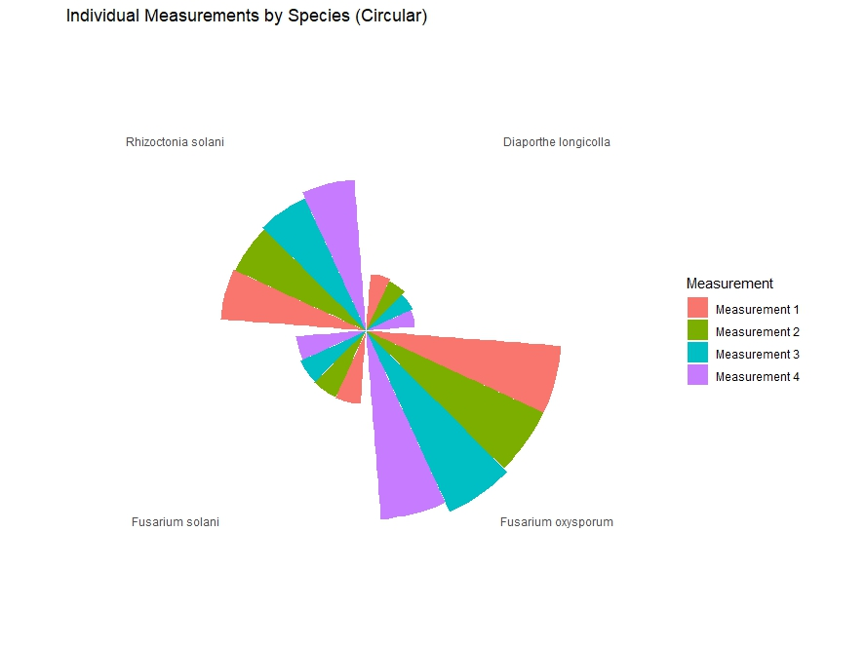

*Figure 4: Circular plot showing the distribution of fungal growth values for each measurement taken across different species.*

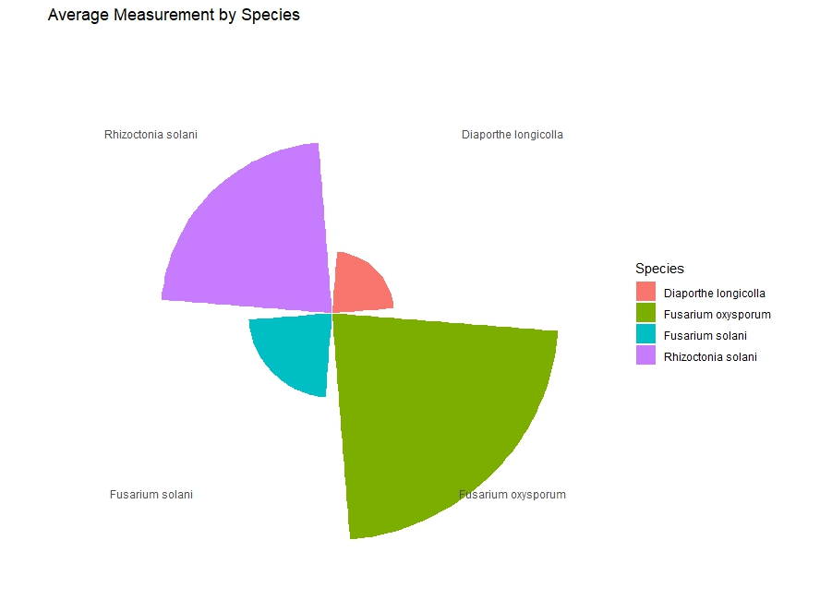

*Figure 5: Circular plot showing the distribution of average fungal growth across different species.*

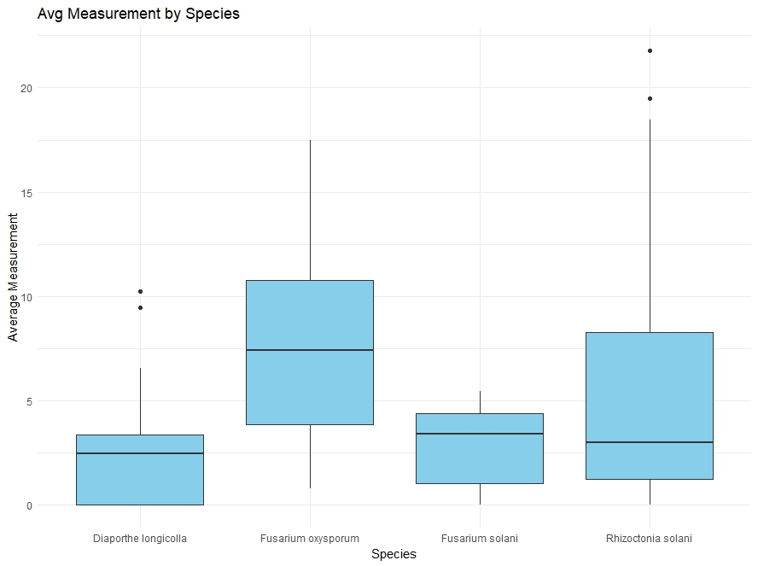

*Figure 6: Boxplot showing the distribution of average fungal growth measurements across species.*

Figure 7 shows the distribution of average fungal growth measurements across different fungicide dose levels, split by fungal species. For Diaporthe longicolla species, the following dose: 6.292, 5.7975, 4.9128, 0.6292, 0.57975, 0.49128, 0.06292, and 0.057975, resulted in complete death of fungal growth, as shown by an absence of measured growth i.e. growth = 0. Also, for Fusarium solani, the following doses: 6.292, 0.6292, and 0.06292 completely killed the development of the fungus. However, for Fusarium oxysporum, we saw some resistance to the fungicide treatment dose as there were observable groth of the fungus across all dose level. Same was also observed for Rhizotonia solani.

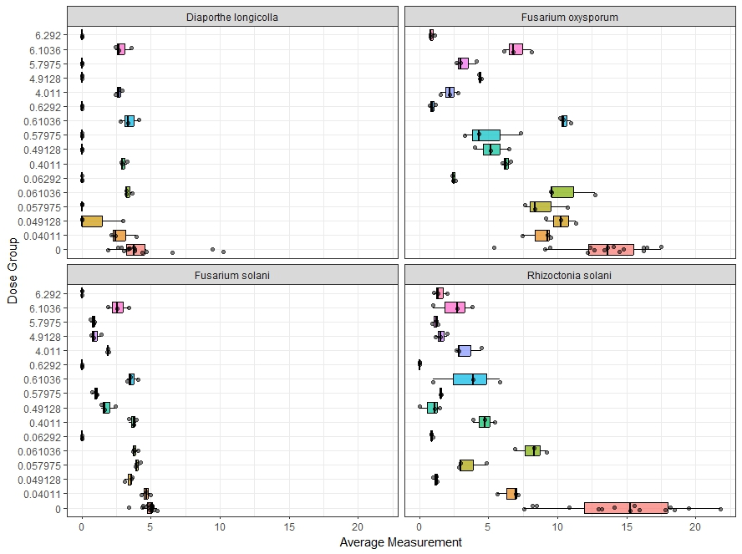 *Figure 7: Boxplot showing the distribution of average fungal growth measurements across different doses for each species.*

Figure 8 shows the distribution of average fungal growth across different fungicide dose levels, split by fungicide treatment. This plot showed that specific dose was used in each of the treatment, this showed the nested structure of dose within treatment. From the plot, we observed that across all the treatments, fungal growth decreased with increase in the level of the fungicide dose.

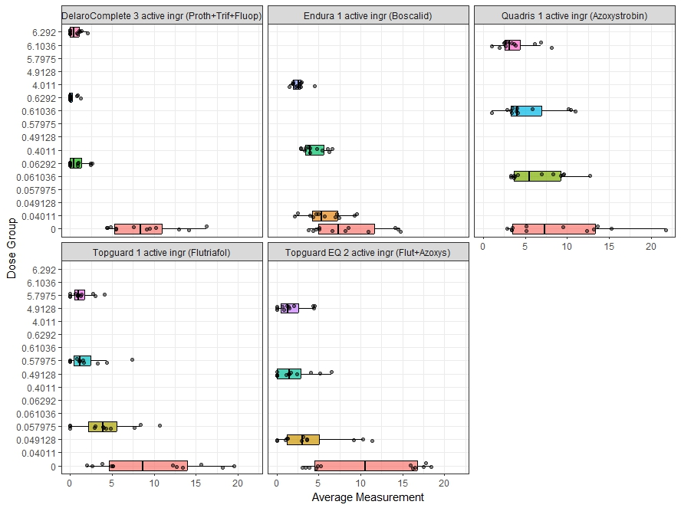

*Figure 8: Boxplot showing the distribution of average fungal growth measurements across*

Figure 9 shows the histogram of the average fungal measurements. The distribution is right-skewed, with a high concentration of observations clustered at lower growth values.

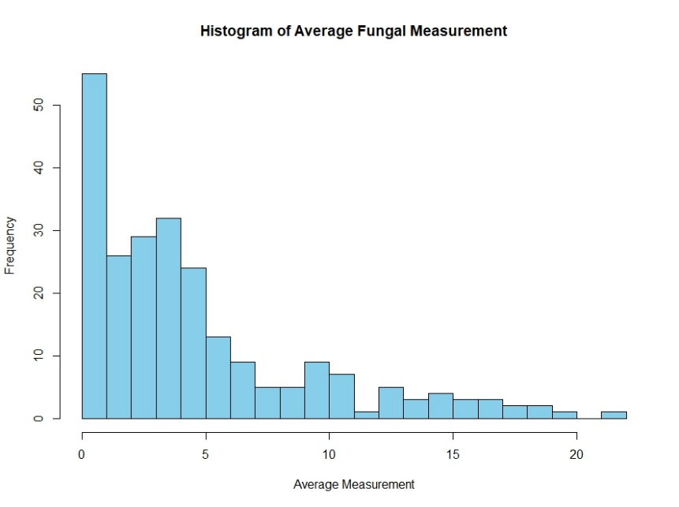

Figure 9: Histogram of average fungal measurements

**Advanced Analysis**

The major goal of performing this experiment is to determine the effectiveness of fungicides against resistant pathogens.

**Random Effect Structure:**

This part of the result shows the nested structure variability in both the conditional and the zero-inflated model.

**Conditional Model Variance Components:**

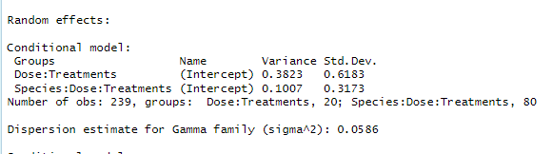

*Dose:Treatments: Variance = 0.3823 (SD = 0.6183)*

*Species:Dose:Treatments: Variance = 0.1007 (SD = 0.3173)*

This result shows the variability in the pathogens growth for dose nested in treatment and also for species crossed with treatment nested within dose i.e. variability in how each species respond to the different fungicide (dose treatment combination). The variation in the growth of the pathogens due to the random effect of dose nested within treatments is 0.3823 and the variation in the growth of the pathogens due to the random effect of species crossed with treatments nested within dose is 0.1007.

**Fixed Effect Structure:**

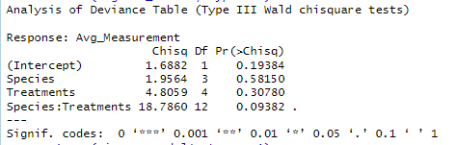

The result above shows the ANOVA table for the effect of species, treatments and the interaction between treatments and species for the gamma regression section of the zero-inflated model. The result showed that a marginal significant interaction between species and treatment (p > 0.05). We looked further to see which of the treatment and species combination differs in growth.

The table below shows the interaction between fungal species and different treatment with respect to their average growth. The result showed a statistically significant interaction between fusarium oxysporum species and asoxystrobin treatments (p = 0.0115).

Table: Interaction between Species and Treatments on Average Growth

|  |  |  |  |  |  |  |  |
| --- | --- | --- | --- | --- | --- | --- | --- |
| Species | Treatments | df | Average Growth | SE | LCL | UCL | p |
| Diaporthe longicolla | (Proth+Trif+Fluop) | 3 | 1.96 | 1.01 | 0.711 | 5.38 | 0.4564 |
| Fusarium oxysporum | (Proth+Trif+Fluop) | 3 | 2.2 | 0.78 | 1.098 | 4.41 | 0.4081 |
| Fusarium solani | (Proth+Trif+Fluop) | 3 | 1.2 | 0.618 | 0.435 | 3.29 | 0.1263 |
| Rhizoctonia solani | (Proth+Trif+Fluop) | 3 | 2.05 | 0.778 | 0.975 | 4.31 | 0.3553 |
| Diaporthe longicolla | (Boscalid) | 1 | 3.31 | 1.17 | 1.651 | 6.62 | 0.9614 |
| Fusarium oxysporum | (Boscalid) | 1 | 6.52 | 2.31 | 3.255 | 13.06 | 0.1217 |
| Fusarium solani | (Boscalid) | 1 | 3.58 | 1.27 | 1.787 | 7.17 | 0.8737 |
| Rhizoctonia solani | (Boscalid) | 1 | 5.61 | 1.99 | 2.802 | 11.24 | 0.2203 |
| Diaporthe longicolla | (Azoxystrobin) | 1 | 3.27 | 1.16 | 1.631 | 6.55 | 0.9614 |
| Fusarium oxysporum | (Azoxystrobin) | 1 | 9.9 | 3.51 | 4.941 | 19.83 | 0.0115 |
| Fusarium solani | (Azoxystrobin) | 1 | 3.61 | 1.28 | 1.803 | 7.24 | 0.8737 |
| Rhizoctonia solani | (Azoxystrobin) | 1 | 5.99 | 2.12 | 2.988 | 11.99 | 0.1632 |
| Diaporthe longicolla | (Flutriafol) | 1 | 1.05 | 0.52 | 0.399 | 2.77 | 0.1029 |
| Fusarium oxysporum | (Flutriafol) | 1 | 6.61 | 2.34 | 3.3 | 13.25 | 0.1217 |
| Fusarium solani | (Flutriafol) | 1 | 2.03 | 0.719 | 1.012 | 4.06 | 0.3336 |
| Rhizoctonia solani | (Flutriafol) | 1 | 3.32 | 1.18 | 1.657 | 6.67 | 0.9614 |
| Diaporthe longicolla | (Flut+Azoxys) | 2 | 1.89 | 0.785 | 0.835 | 4.27 | 0.3336 |
| Fusarium oxysporum | (Flut+Azoxys) | 2 | 8.01 | 2.84 | 3.999 | 16.05 | 0.0519 |
| Fusarium solani | (Flut+Azoxys) | 2 | 2.37 | 0.841 | 1.184 | 4.75 | 0.5016 |
| Rhizoctonia solani | (Flut+Azoxys) | 2 | 2.6 | 0.926 | 1.298 | 5.23 | 0.6934 |

The table showed the significant pairwise comparisons between species and treatment combinations. Diaporthe longicolla showed 0.33 times lower average growth compared to Fusarium oxysporum under Flutriafol treatment. Fusarium oxysporum showed 2.741 times higher average growth compared to Fusarium solani under Azoxystrobin treatment. Fusarium oxysporum under Azoxystrobin treatment showed 9.412 times higher average growth compared to Diaporthe longicolla under Flutriafol treatment. Diaporthe longicolla average growth is 0.159 times lower than Fusarium oxysporum average growth under Flutriafol treatment. Fusarium oxysporum species average growth is 3.26 greater than Fusarium solani species average growth when treated with Flutriafol. Diaporthe longicolla species average growth is 0.236 lower than Fusarium oxysporum species average growth when treated with Flut+Azoxys. Fusarium oxysporum species average growth is 3.378 greater than Fusarium solani species average growth when treated with Flut+Azoxys. Fusarium oxysporum species average growth is 3.075 greater than Rhizoctonia solani species average growth when treated with Flut+Azoxys.

Table: Pairwise Difference

|  |  |  |  |  |  |
| --- | --- | --- | --- | --- | --- |
|  | Ratio | SE | LCL | UCL | p-value |
| Diaporthe longicolla (Azoxystrobin) / Fusarium oxysporum (Azoxystrobin) | 0.33 | 0.081 | 0.1384 | 0.787 | 0.0011 |
| Fusarium oxysporum (Azoxystrobin) / Fusarium solani (Azoxystrobin) | 2.741 | 0.672 | 1.1489 | 6.537 | 0.0063 |
| Fusarium oxysporum (Azoxystrobin) / Diaporthe longicolla (Flutriafol) | 9.412 | 5.73 | 1.0886 | 81.381 | 0.0313 |
| Diaporthe longicolla (Flutriafol) / Fusarium oxysporum (Flutriafol) | 0.159 | 0.0674 | 0.0354 | 0.714 | 0.0024 |
| Fusarium oxysporum (Flutriafol) / Fusarium solani (Flutriafol) | 3.26 | 0.8 | 1.3664 | 7.776 | 0.0003 |
| Diaporthe longicolla (Flut+Azoxys) / Fusarium oxysporum (Flut+Azoxys) | 0.236 | 0.0773 | 0.0736 | 0.754 | 0.0018 |
| Fusarium oxysporum (Flut+Azoxys) / Fusarium solani (Flut+Azoxys) | 3.378 | 0.829 | 1.416 | 8.058 | 0.0001 |
| Fusarium oxysporum (Flut+Azoxys) / Rhizoctonia solani (Flut+Azoxys) | 3.075 | 0.759 | 1.2826 | 7.374 | 0.0009 |

**Note: Only extracted significant pairwise difference**

The table below shows the Best Linear Unbiased Predictor (BLUP) for the random factor (dose nested within treatment and species crossed with dose nested within treatment) included in the model. The BLUP result describes the effect of each of the levels of the nested structure on average fungal growth. The value and sign as shown in the result below describes the size and direction of the effect respectively.

The result from the BLUP output below shows that the highest predicted fungal growth per each of the treatment was observed when dose was equal to zero. At dose = 0, the treatment DelaroComplete 3 active ingr (Proth+Trif+Fluop) has the highest predicted fungal growth (BLUP = 1.41), followed by Topguard 1 active ingr (Flutriafol) (BLUP = 0.98), Topguard EQ 2 active ingr (Flut+Azoxys) (BLUP = 0.92), Endura 1 active ingr (Boscalid) (BLUP = 0.46), and Quadris 1 active ingr (Azoxystrobin) (BLUP = 0.33).

For DelaroComplete 3 active ingr (Proth+Trif+Fluop) treatment, increasing the dose showed a deceasing trend in the BLUP values, suggesting that higher doses for this treatment is associated with a reduced fungal growth.

For Endura 1 active ingr (Boscalid), the predicted average growth at dose of 0.04011 is 0.13 i.e. the fungal are predicted to grow by 0.13 for the 0.04011: Boscalid dose treatment combination, however increasing the dosage to 0.4011 and 4.011 showed a decrease in the average growth of the fungal.

For Quadris 1 active ingr (Azoxystrobin), Topguard 1 active ingr (Flutriafol), and Topguard EQ 2 active ingr (Flut+Azoxys), we also observed an increase in the predicted growth of fungus for the second dose level. However, the third and fourth level showed a decrease in the predicted growth of fungus.

Table: Best Linear Unbiased Prediction for Dose nested within treatment

|  |  |
| --- | --- |
| Dose:Treatments | BLUP |
| 0:DelaroComplete 3 active ingr (Proth+Trif+Fluop) | 1.41183167 |
| 0.06292:DelaroComplete 3 active ingr (Proth+Trif+Fluop) | -0.29376098 |
| 0.6292:DelaroComplete 3 active ingr (Proth+Trif+Fluop) | -0.63164527 |
| 6.292:DelaroComplete 3 active ingr (Proth+Trif+Fluop) | -0.51709871 |
| 0:Endura 1 active ingr (Boscalid) | 0.46442025 |
| 0.04011:Endura 1 active ingr (Boscalid) | 0.13117696 |
| 0.4011:Endura 1 active ingr (Boscalid) | -0.06144593 |
| 4.011:Endura 1 active ingr (Boscalid) | -0.56587294 |
| 0:Quadris 1 active ingr (Azoxystrobin) | 0.33269808 |
| 0.061036:Quadris 1 active ingr (Azoxystrobin) | 0.10948531 |
| 0.61036:Quadris 1 active ingr (Azoxystrobin) | -0.0933132 |
| 6.1036:Quadris 1 active ingr (Azoxystrobin) | -0.38060329 |
| 0:Topguard 1 active ingr (Flutriafol) | 0.97812746 |
| 0.057975:Topguard 1 active ingr (Flutriafol) | 0.3180565 |
| 0.57975:Topguard 1 active ingr (Flutriafol) | -0.52031834 |
| 5.7975:Topguard 1 active ingr (Flutriafol) | -0.80848228 |
| 0:Topguard EQ 2 active ingr (Flut+Azoxys) | 0.92044363 |
| 0.049128:Topguard EQ 2 active ingr (Flut+Azoxys) | 0.05013726 |
| 0.49128:Topguard EQ 2 active ingr (Flut+Azoxys) | -0.40679298 |
| 4.9128:Topguard EQ 2 active ingr (Flut+Azoxys) | -0.59860489 |

A Best Linear Unbiased Prediction (BLUP) was conducted to estimate the random effects of Species crossed with Dose nested within Treatment, on fungal growth.

For Diaporthe longicolla species, the DelaroComplete (Proth+Trif+Fluop) and Topguard (Flutriafol) treatment showed little decrease with values close to zero in BLUP estimates for dose 0 while for other dose, fungus growth neither increase nor decrease. This suggests that fungal growth under this treatment remained relatively stable when the dose was increased. Endura (Boscalid) showed the highest positive BLUP at dose 4.011 (BLUP = 0.298), indicating increased fungal growth at this dose compared to lower concentrations. However, at lower doses (0.00, 0.04011 and 0.4011), the BLUP estimates were negative, suggesting a decrease in fungal growth. Quadris (Azoxystrobin) demonstrated negative BLUP estimates at lower doses (BLUP = -0.282 at dose 0 and -0.063 at dose 0.061) but increased at higher doses (BLUP = 0.12 and 0.22 at 0.61036 and 6.1036 respectively). For Topguard EQ (Flut+Azoxys), the prediction showed that fungal growth reduced at dose 0, predicted increase in growth by 0.265 at dose 0.049128 while at dose 0.49128 and 4.9128, there fungus growth neither increase nor decrease.

For Fusarium oxysporum species treated with DelaroComplete 3 active ingr (Proth+Trif+Fluop) and Quadris 1 active ingr (Azoxystrobin), the Best Linear Unbiased Prediction result showed an increase in fungus growth for the first two dose while the fungus growth reduced for the other dose. For Fusarium oxysporum species treated with Endura 1 active ingr (Boscalid), the Best Linear Unbiased Prediction result showed an increase in fungus growth for the first three dose (0.0, 0.04011, and 0.4011) while it predicted a reduction in the growth of fungus for dose 4.011. For Fusarium oxysporum species treated Topguard 1 active ingr (Flutriafol), BLUP predicted a decrease in growth for dose level 0 and 0.057975 while the other two level is predicted to increase growth in this specie. For Fusarium oxysporum species treated with Topguard EQ 2 active ingr (Flut+Azoxys), the Best Linear Unbiased Prediction result showed an increase in fungus growth for dose 0.049128 and 4.9128 while the other two dose were predicted to reduce growth of fungus.

For Fusarium solani species treated with DelaroComplete 3 active ingr (Proth+Trif+Fluop), dose 0 showed a reduction in growth while the other dose level showed a zero growth. For Fusarium solani species treated with Endura 1 active ingr (Boscalid), dose 0 and 4.011 showed a reduction in growth while BLUP predicted an increase in growth for dose 0.04011, and 0.4011. For Fusarium solani species treated with Topguard 1 active ingr (Flutriafol), BLUP predicted a reduction in growth at dose 0, 0.57975, and 5.7975 while growth was predicted to increase at dose level 0.057975. For Fusarium solani species treated with Topguard EQ 2 active ingr (Flut+Azoxys), dose 0 and 4.9128 showed a reduction in growth while BLUP predicted an increase in growth for dose 0.049128, and 0.49128.

For Rhizoctonia solani species treated with DelaroComplete 3 active ingr (Proth+Trif+Fluop) , BLUP showed that dose 0 and 6.292 increased the fungus growth, dose 0.06292 reduced the fungus growth while dose 0.6292 neither increased nor decrease the growth of fungus. With Endura 1 active ingr (Boscalid) treatment, dose 0.4011 was predicted to reduce the growth of fungus while the other dose level increased fungus growth. For Quadris 1 active ingr (Azoxystrobin) treatment, dose 0 and 0.061036 increased fungus growth while the other two dose was predicted to reduce dose. For Topguard 1 active ingr (Flutriafol), dose 0 and 5.7975 was predicted to increase fungus growth, while other dose level decreased the growth of fungus. With Topguard EQ 2 active ingr (Flut+Azoxys), dose 0 and 4.9128 increased the growth of fungus while dose 0.049128 and 0.49128 was predicted to reduce their growth.

Table: Best Linear Unbiased Prediction for species crossed with dose nested within treatment.

|  |  |  |
| --- | --- | --- |
|  | Species:Dose:Treatments | BLUP |
| Diaporthe longicolla | 0:DelaroComplete 3 active ingr (Proth+Trif+Fluop) | -0.000616511 |
|  | 0.06292:DelaroComplete 3 active ingr (Proth+Trif+Fluop) | 0 |
|  | 0.6292:DelaroComplete 3 active ingr (Proth+Trif+Fluop) | 0 |
|  | 6.292:DelaroComplete 3 active ingr (Proth+Trif+Fluop) | 0 |
|  | 0:Endura 1 active ingr (Boscalid) | -0.041562794 |
|  | 0.04011:Endura 1 active ingr (Boscalid) | -0.237818396 |
|  | 0.4011:Endura 1 active ingr (Boscalid) | -0.021039568 |
|  | 4.011:Endura 1 active ingr (Boscalid) | 0.298317876 |
|  | 0:Quadris 1 active ingr (Azoxystrobin) | -0.282390186 |
|  | 0.061036:Quadris 1 active ingr (Azoxystrobin) | -0.062961318 |
|  | 0.61036:Quadris 1 active ingr (Azoxystrobin) | 0.121451677 |
|  | 6.1036:Quadris 1 active ingr (Azoxystrobin) | 0.221821793 |
|  | 0:Topguard 1 active ingr (Flutriafol) | -0.000574947 |
|  | 0.057975:Topguard 1 active ingr (Flutriafol) | 0 |
|  | 0.57975:Topguard 1 active ingr (Flutriafol) | 0 |
|  | 5.7975:Topguard 1 active ingr (Flutriafol) | 0 |
|  | 0:Topguard EQ 2 active ingr (Flut+Azoxys) | -0.271722003 |
|  | 0.049128:Topguard EQ 2 active ingr (Flut+Azoxys) | 0.265117379 |
|  | 0.49128:Topguard EQ 2 active ingr (Flut+Azoxys) | 0 |
|  | 4.9128:Topguard EQ 2 active ingr (Flut+Azoxys) | 0 |
| Fusarium oxysporum | 0:DelaroComplete 3 active ingr (Proth+Trif+Fluop) | 0.106100059 |
|  | 0.06292:DelaroComplete 3 active ingr (Proth+Trif+Fluop) | 0.355692318 |
|  | 0.6292:DelaroComplete 3 active ingr (Proth+Trif+Fluop) | -0.166327429 |
|  | 6.292:DelaroComplete 3 active ingr (Proth+Trif+Fluop) | -0.299732171 |
|  | 0:Endura 1 active ingr (Boscalid) | 0.278496151 |
|  | 0.04011:Endura 1 active ingr (Boscalid) | 0.136230476 |
|  | 0.4011:Endura 1 active ingr (Boscalid) | 0.019989513 |
|  | 4.011:Endura 1 active ingr (Boscalid) | -0.436805234 |
|  | 0:Quadris 1 active ingr (Azoxystrobin) | -0.129392723 |
|  | 0.061036:Quadris 1 active ingr (Azoxystrobin) | -0.034205375 |
|  | 0.61036:Quadris 1 active ingr (Azoxystrobin) | 0.128827724 |
|  | 6.1036:Quadris 1 active ingr (Azoxystrobin) | 0.032736257 |
|  | 0:Topguard 1 active ingr (Flutriafol) | -0.268141692 |
|  | 0.057975:Topguard 1 active ingr (Flutriafol) | -0.017637166 |
|  | 0.57975:Topguard 1 active ingr (Flutriafol) | 0.200686125 |
|  | 5.7975:Topguard 1 active ingr (Flutriafol) | 0.083511652 |
|  | 0:Topguard EQ 2 active ingr (Flut+Azoxys) | -0.153415918 |
|  | 0.049128:Topguard EQ 2 active ingr (Flut+Azoxys) | 0.164391125 |
|  | 0.49128:Topguard EQ 2 active ingr (Flut+Azoxys) | -0.014750217 |
|  | 4.9128:Topguard EQ 2 active ingr (Flut+Azoxys) | 0.004023557 |
| Fusarium solani | 0:DelaroComplete 3 active ingr (Proth+Trif+Fluop) | -0.000625527 |
|  | 0.06292:DelaroComplete 3 active ingr (Proth+Trif+Fluop) | 0 |
|  | 0.6292:DelaroComplete 3 active ingr (Proth+Trif+Fluop) | 0 |
|  | 6.292:DelaroComplete 3 active ingr (Proth+Trif+Fluop) | 0 |
|  | 0:Endura 1 active ingr (Boscalid) | -0.13874485 |
|  | 0.04011:Endura 1 active ingr (Boscalid) | 0.110523464 |
|  | 0.4011:Endura 1 active ingr (Boscalid) | 0.080927519 |
|  | 4.011:Endura 1 active ingr (Boscalid) | -0.05479903 |
|  | :0:Quadris 1 active ingr (Azoxystrobin) | -0.088966249 |
|  | 0.061036:Quadris 1 active ingr (Azoxystrobin) | -0.04005418 |
|  | 0.61036:Quadris 1 active ingr (Azoxystrobin) | 0.078676058 |
|  | 6.1036:Quadris 1 active ingr (Azoxystrobin) | 0.048275351 |
|  | 0:Topguard 1 active ingr (Flutriafol) | -0.062226152 |
|  | 0.057975:Topguard 1 active ingr (Flutriafol) | 0.308842891 |
|  | 0.57975:Topguard 1 active ingr (Flutriafol) | -0.158526749 |
|  | 5.7975:Topguard 1 active ingr (Flutriafol) | -0.089786457 |
|  | 0:Topguard EQ 2 active ingr (Flut+Azoxys) | -0.160570939 |
|  | 0.049128:Topguard EQ 2 active ingr (Flut+Azoxys) | 0.272726683 |
|  | 0.49128:Topguard EQ 2 active ingr (Flut+Azoxys) | 0.124419505 |
|  | 4.9128:Topguard EQ 2 active ingr (Flut+Azoxys) | -0.236335868 |
| Rhizoctonia solani | 0:DelaroComplete 3 active ingr (Proth+Trif+Fluop) | 0.266911298 |
|  | 0.06292:DelaroComplete 3 active ingr (Proth+Trif+Fluop) | -0.433046666 |
|  | 0.6292:DelaroComplete 3 active ingr (Proth+Trif+Fluop) | 0 |
|  | 6.292:DelaroComplete 3 active ingr (Proth+Trif+Fluop) | 0.163567614 |
|  | 0:Endura 1 active ingr (Boscalid) | 0.02410454 |
|  | 0.04011:Endura 1 active ingr (Boscalid) | 0.025606511 |
|  | 0.4011:Endura 1 active ingr (Boscalid) | -0.09605766 |
|  | 4.011:Endura 1 active ingr (Boscalid) | 0.044278398 |
|  | 0:Quadris 1 active ingr (Azoxystrobin) | 0.588356584 |
|  | 0.061036:Quadris 1 active ingr (Azoxystrobin) | 0.166050995 |
|  | 0.61036:Quadris 1 active ingr (Azoxystrobin) | -0.353527076 |
|  | 6.1036:Quadris 1 active ingr (Azoxystrobin) | -0.403055423 |
|  | 0:Topguard 1 active ingr (Flutriafol) | 0.588507333 |
|  | 0.057975:Topguard 1 active ingr (Flutriafol) | -0.20745378 |
|  | 0.57975:Topguard 1 active ingr (Flutriafol) | -0.179171739 |
|  | 5.7975:Topguard 1 active ingr (Flutriafol) | -0.206618072 |
|  | 0:Topguard EQ 2 active ingr (Flut+Azoxys) | 0.828083859 |
|  | 0.049128:Topguard EQ 2 active ingr (Flut+Azoxys) | -0.689032837 |
|  | 0.49128:Topguard EQ 2 active ingr (Flut+Azoxys) | -0.216787688 |
|  | 4.9128:Topguard EQ 2 active ingr (Flut+Azoxys) | 0.074685212 |

**CONCLUSION**

**PROJECT REFLECTION**

On Thursday, February 13, from 11:45 AM to 1:00 PM, I had my initial meeting with my client Kelvin Muchiri. He is currently a Master’s student working at the department of plant pathology and his advisor is Garcia-Aroca Teddy. He is interested in investigating the efficacy of chemical applications in controlling soil-borne pathogens of soybean.

The client indicated on the google form that they are interested in performing a two-way ANOVA and Tukey-HSD tests for their data on investigating the efficacy of chemical applications in controlling soil-borne pathogens of soybean. To be able to follow the prepare section of the POWER process, I mailed the client to ask for their dataset and some information on their previously done analysis prior to meeting since they indicated they have initially conducted some analysis on the data. This helped with getting prepared for our meeting and also helped implement the PREPARE stage of the power process.

During the open phase, we began by introducing ourselves and took some few minutes to establish rapport between myself and the domain expert. Also, before I asked them to give me a more detailed explanation of their project again, we briefly discussed their deadlines, their expectations and I also took the time to explain how I’m going to be helping on the project, after which we transitioned into the work phase. I believe this phase was quite helpful as it kind of set a collaborative and welcoming tone which made the domain expert feel more comfortable.

During the main part of the consultation, which is the work phase, I asked the domain expert to give me detailed explanation of how they conducted the experiment again as it would help me in determining the right approach to model their data. The domain expert ability to clearly provide a pictorial representation of their design was very helpful as it made me see exactly what was going on in their experiment. While describing his experiment, I noticed he had some nested structure he was not aware of and also his dataset contains a lot of zero’s which he also was not bothered about. So I had to explain what a crossed and nested structure is and also asked more question about the information the zero-values were providing. The domain expert showed flexibility and willingness to collaborate, as they were open to suggestionswith regards to analyzing their dataset in alignment with the way their experiment was designed. Their consistent engagement, insightful questions and calling my attention to explain what they do not understand reflected their trust in our expertise and a readiness to co-work with me on the analysis. After the initial meeting a document summarizing the experiment objectives and design was sent to the domain experts in order to be sure everyone is aware of the work we’ve gotten so far and so to ask some other questions that came up when I was reflecting on our meeting.

In general, I had an amazing experience working on this project with the domain-expert. Having the opportunity to collaborate directly with domain experts was a really great experience. I learned so much just listening to them explain their research approach and methodology. It was fascinating to see how they conducted their work in practice. Being part of a real-world project rather than just theoretical exercises really deepened my understanding and made the whole experience worthwhile.

Allen, T., Mueller, D., Sisson, A., Sikora, E., Faske, T., Spurlock, T., Koehler, A., Dufault, N., Small, I., Kemerait, B., Harbach, C., Bond, J., Telenko, D., Mueller, D., Onofre, R., Bradley, C., Padgett, B., Price, T., Watson, T., … Smith, D. (2023). *Soybean Disease Loss Estimates from the United States and Ontario, Canada — 2022*. https://doi.org/10.31274/cpn-20230421-1

CropWatch, I.-U. (n.d.). *Soybean Disease Management*. Retrieved April 28, 2025, from https://cropwatch.unl.edu/plant-disease/soybean/

farmjournal. (2025). *Soybean Blight: How to Identify Pythium, Phytophthora, Fusarium, and Rhizoctonia*. https://www.agweb.com/news/crops/how-identify-soybean-blight

Mills, E. D. (2013). *Adjusting for covariates in zero-inflated gamma and zero-inflated log-normal models for semicontinuous data*. UniversityofIowa.

S Navi, S., & Rajasab, A. (2016). In Vitro Evaluation of Commercial Fungicides against some of the Major Soil Borne Pathogens of Soybean. *Journal of Plant Pathology & Microbiology*, *07*(03). https://doi.org/10.4172/2157-7471.1000340

USDA. (2025). *Production - Soybeans*. https://www.fas.usda.gov/data/production/commodity/2222000